**Screenshots of PHP**

**Connection to the database**

Try catch method to indicate any errors while connecting to the database

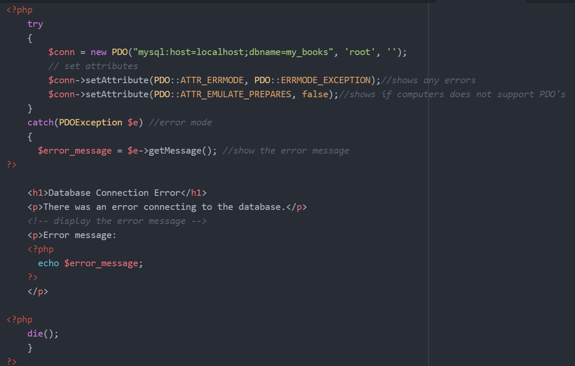

**Password_hash() utilisation**

When the user inputs a password it is sanitised then hashed to be inserted into the database. On login, the password is verified via password_verify()

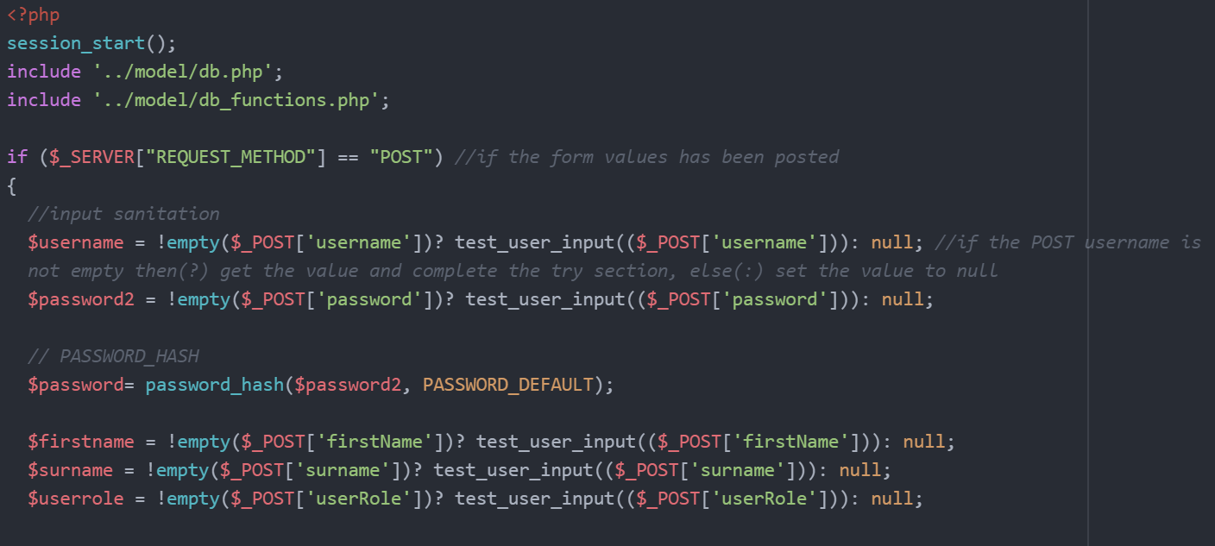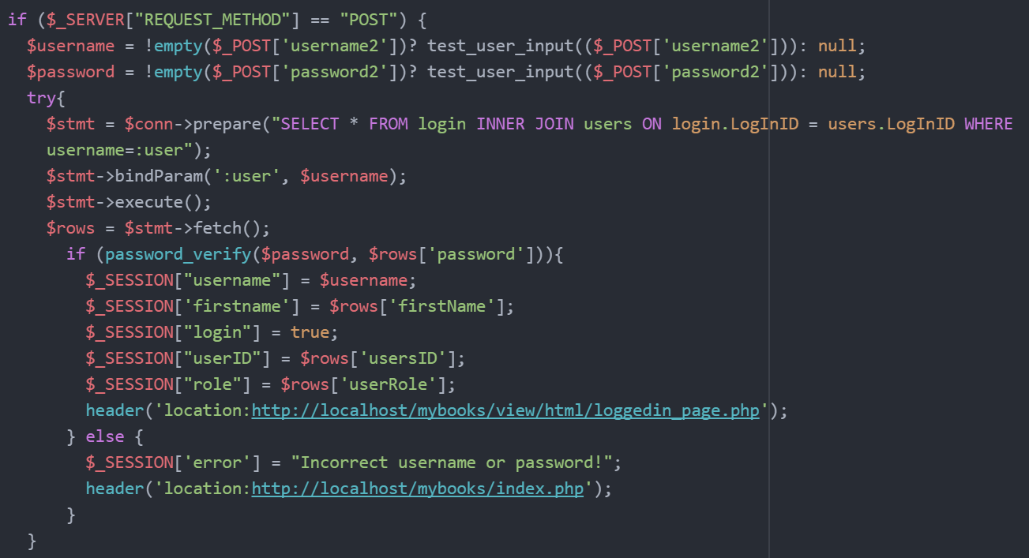

**Data input sanitation**

Input sanitation evident above along with test_user_input()

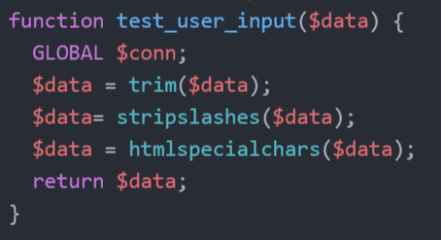

**Insert query statement/s**

I implemented the generic insert query function that can be called at any time.

Used this function for the registration process which includes a transaction. I also used this function to add a book which involves a transaction also.

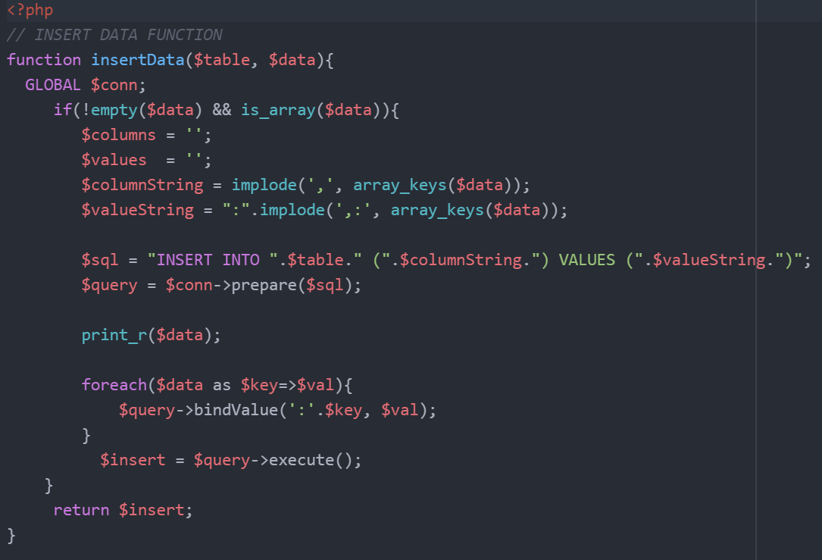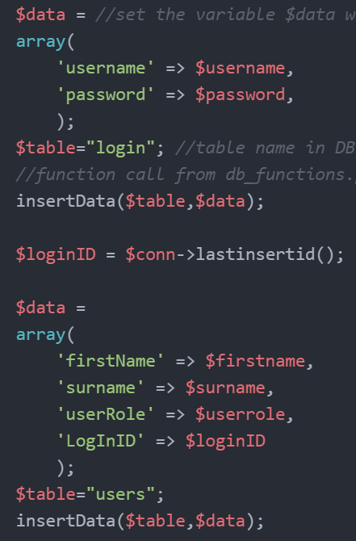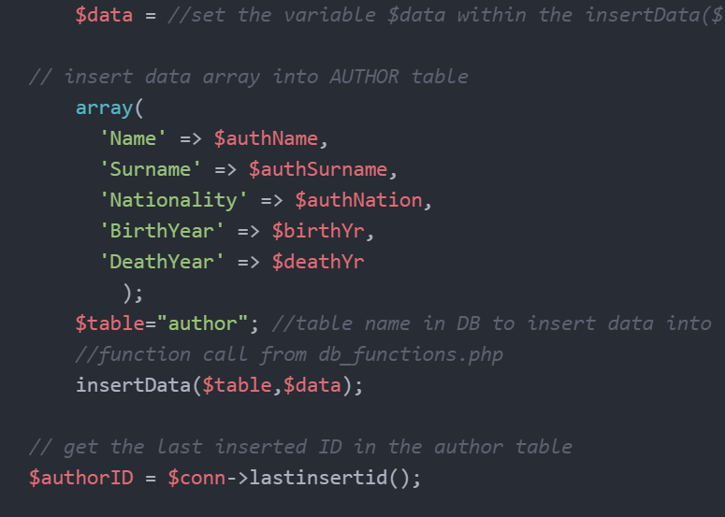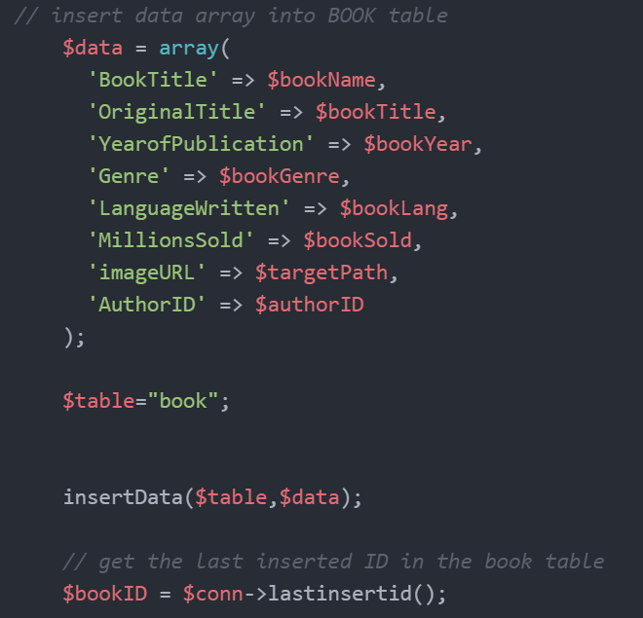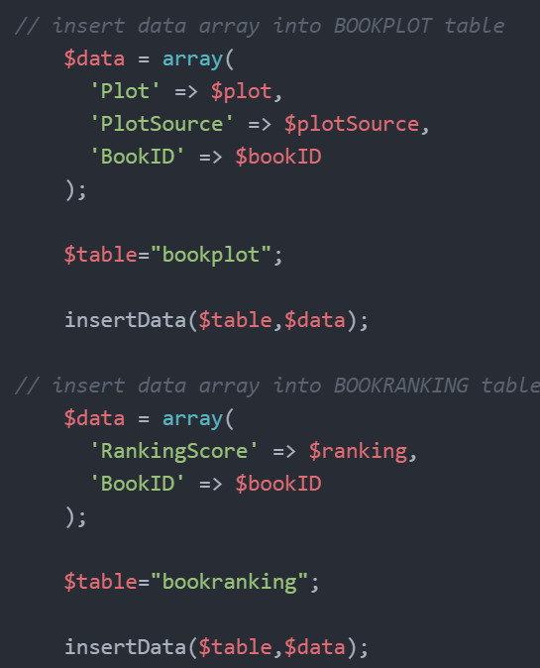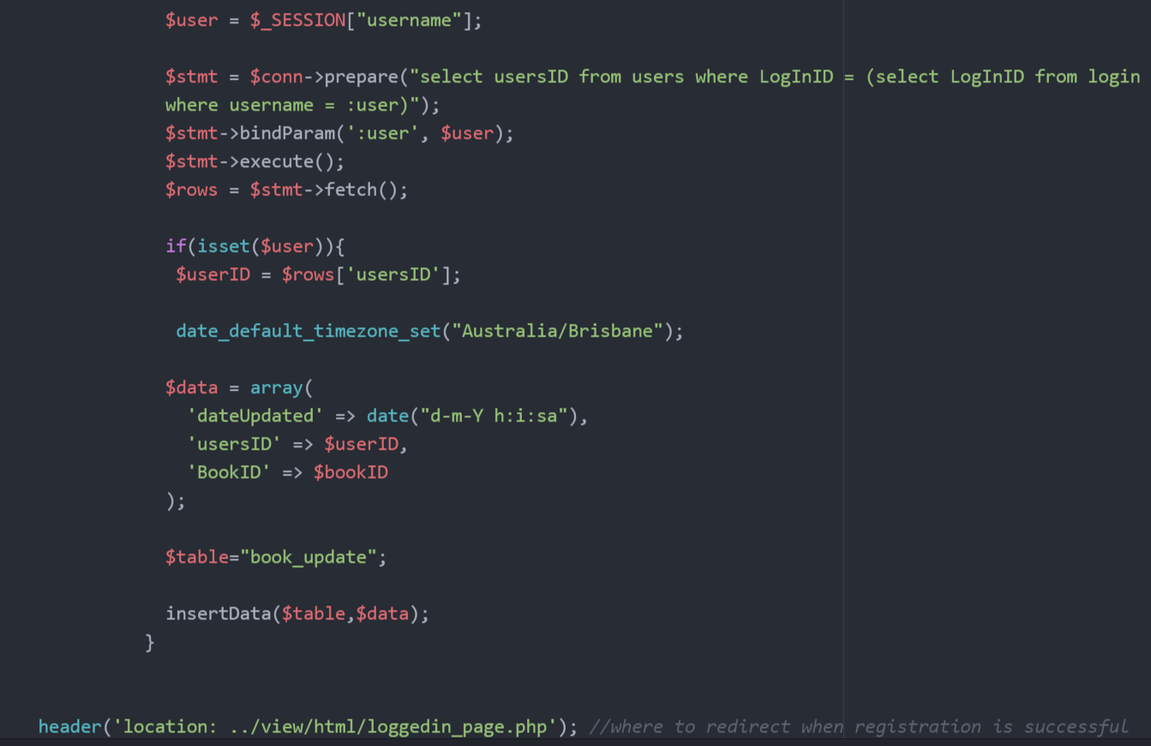

**Update query statement/s**

I stored the update query in a function within db_functions.php. I called this function in the processing file which then proceeds to be processed via AJAX in JS.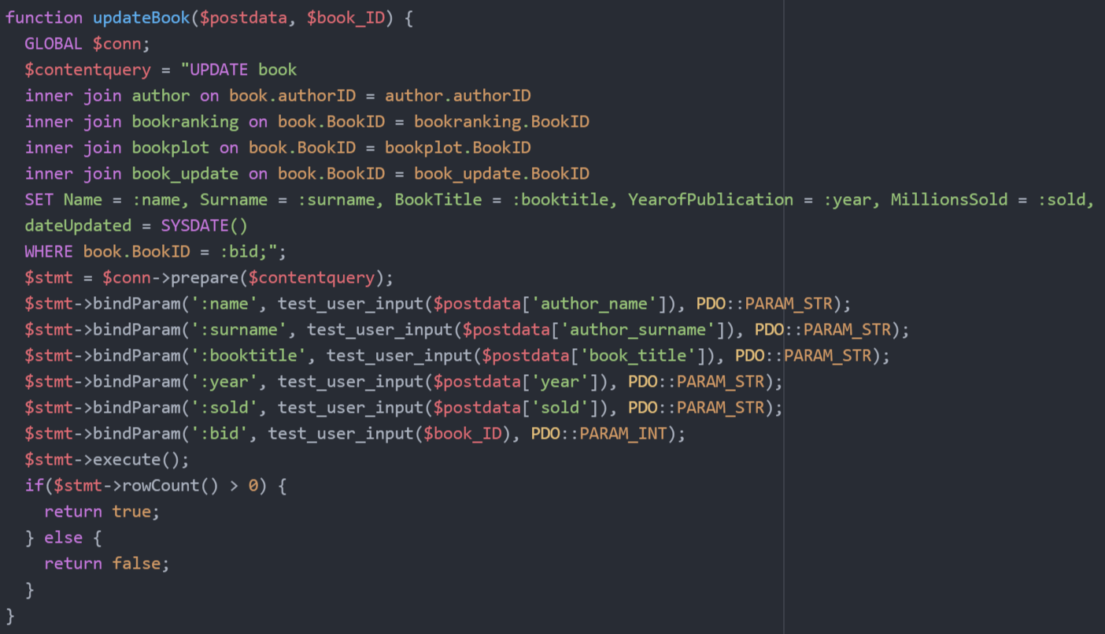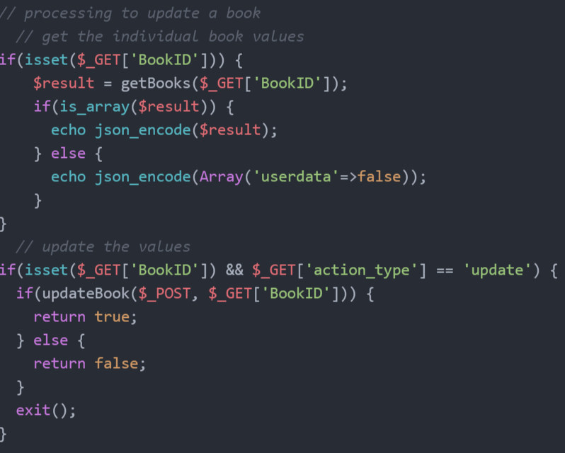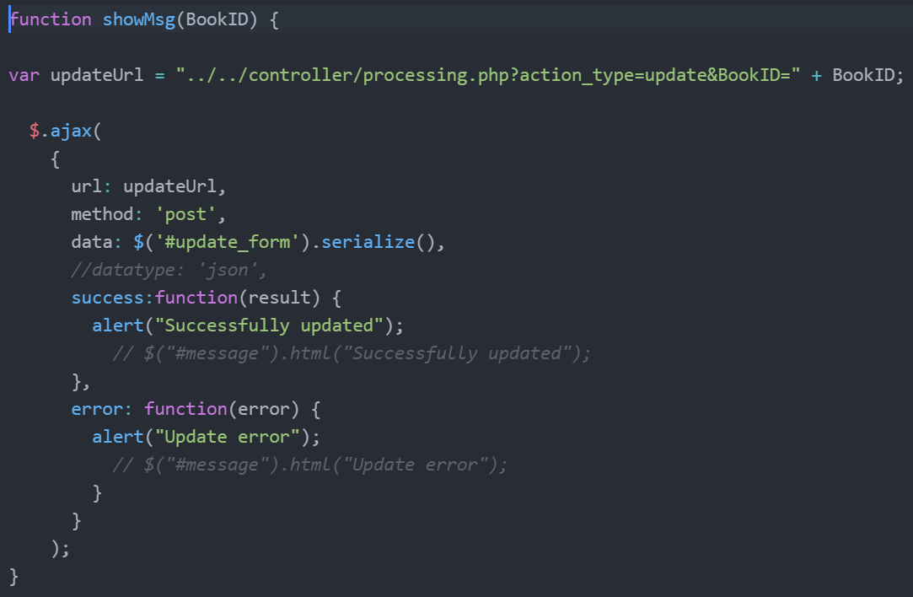

**Delete query statement/s**

I stored the delete query in a function within db_functions.php. I called this function in the processing file which then proceeds to be processed via AJAX in JS.

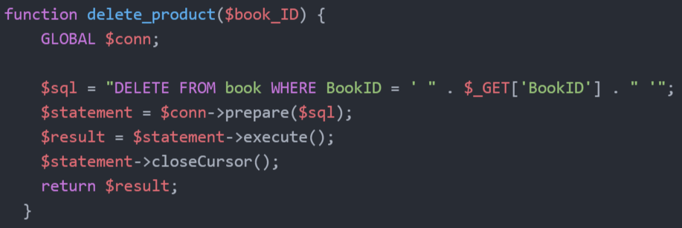

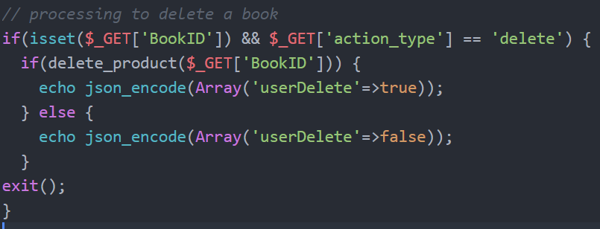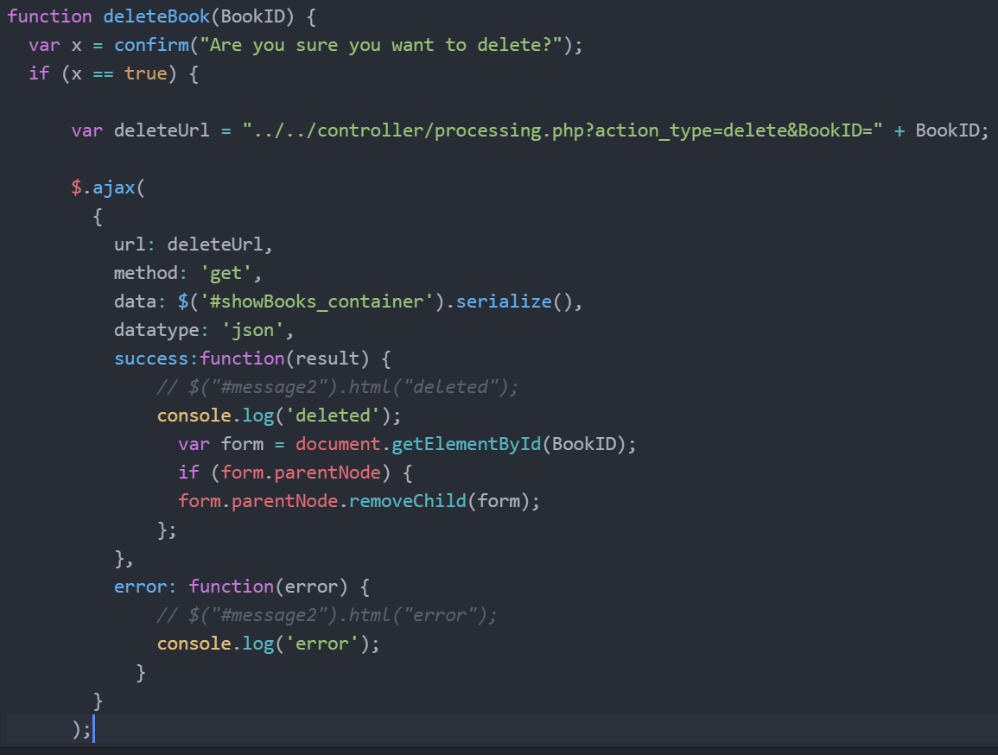

**Session code (create, destroy and redirect)**

I inserted session_start() on all relevant files. While logging out I did not session_destroy() as I wanted to keep the same session_id() each time the user enters the site on the same browser. Instead I unset all the $_SESSION variables and redirected them to the index page.

